Experiment Number : 10 Date: 01.03.26

Implementation of Access Modifiers in Java

Aim:
Write a Java program to implement different access modifiers.

PRE LAB EXERCISE
QUESTIONS
- What are the 4 access modifiers available in Java?
The four access modifiers in Java are:
public
private
protected
default

- Which access modifiers can be used in Java to control access to class members?
The access modifiers that can be used to control access to class members (variables, methods, constructors) are:
public
private
protected
default

IN LAB EXERCISE
Objective
To demonstrate different access modifiers such as Default, Private, Protected and Public using Java programs.
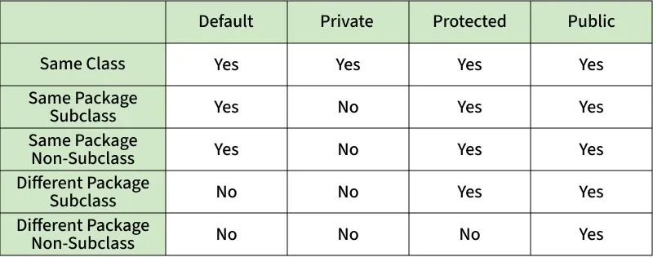
Fig: Comparison table of Access Modifiers in Java
Source Code
// Default Access modifier
class Car {
String model; // default access
}
public class Main {
public static void main(String[] args){
Car c = new Car();
c.model = "Tesla"; // accessible within the same package
System.out.println(c.model);
}
}
Output:
Tesla
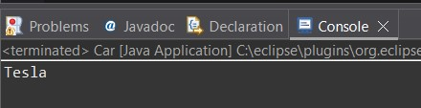
//Private Access Modifier
class Person {
// private variable
private String name;
public void setName(String name) {
this.name = name; // accessible within class
}
public String getName() {
return name;
}
}
public class Geeks {
public static void main(String[] args)
{
Person p = new Person();
p.setName("Alice");

// System.out.println(p.name);
// Error: 'name'
// has private access
System.out.println(p.getName());
}
}
Output
Alice
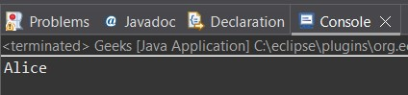
//Protected Access Modifier
class Vehicle {
protected int speed; // protected member
}
class Bike extends Vehicle {
void setSpeed(int s)
{
speed = s; // accessible in subclass
}
int getSpeed()
{
return speed; // accessible in subclass
}
}
public class Main {
public static void main(String[] args){
Bike b = new Bike();
b.setSpeed(100);
System.out.println("Access via subclass method: "+ b.getSpeed());
Vehicle v = new Vehicle();
System.out.println(v.speed);
}
}
Output
Access via subclass method: 100
0
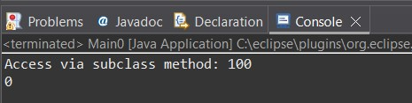
//Public Access Modifier
class MathUtils {
public static int add(int a, int b) {
return a + b;
}
}
public class Main {
public static void main(String[] args) {
System.out.println(MathUtils.add(5, 10)); // accessible anywhere
}
}
Output
15
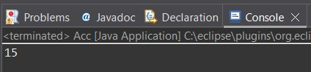
POST LAB EXERCISE
  - Write a Java program to implement Default access modifier which has a default class within the same package and a default class from a different package.

Step 1: Create package packageA with a default class (no access modifier)
File: packageA/DefaultClassA.java
package packageA;

// Default access class (no public/private/protected)
class DefaultClassA {
void display() {
System.out.println("Inside DefaultClassA (packageA)");
}
}

Step 2: Create another class in the same package accessing DefaultClassA
File: packageA/SamePackageTest.java
package packageA;

public class SamePackageTest {
public static void main(String[] args) {
DefaultClassA obj = new DefaultClassA(); // Allowed: same package
obj.display();
}
}

Step 3: Create a class in a different package trying to access DefaultClassA
File: packageB/DifferentPackageTest.java
package packageB;

import packageA.DefaultClassA;

public class DifferentPackageTest {
public static void main(String[] args) {
// DefaultClassA is not visible here; this will cause a compile error
// Uncommenting below lines will cause error
// DefaultClassA obj = new DefaultClassA();
// obj.display();

System.out.println("Cannot access DefaultClassA from different package due to default access modifier");
}
}

  - Which access modifier provides the highest level of access?
public provides the highest level of access.
A public class or method is accessible:
- Within the same class
- Within the same package
- From any other package
- Everywhere in the project
So among all modifiers, public is the most accessible.

ASSESSMENT

Description | Max Marks | Marks Awarded
Pre Lab Exercise | 5
In Lab Exercise | 10
Post Lab Exercise | 5
Viva | 10
Total | 30
Faculty Signature

Experiment Number :11 Date: 02.03.26

Implementation of multiple inheritance in Java using Interface

Aim:
Write a Java program to implement multiple inheritance using Interface.

PRE LAB EXERCISE
QUESTIONS
- Why Java does not support multiple inheritance using classes like that of C?
Java does not support multiple inheritance using classes to avoid ambiguity problems such as the diamond problem, and to keep the language simple, clear, and less error-prone.

- What is the primary purpose of an interface in Java?
- To store data using instance variables
- To define a contract of methods a class must implement
- To allow creation of objects
- To improve runtime performance

B. To define a contract of methods a class must implement
Reason:
Interfaces specify what a class must do, but not how.
They support abstraction and multiple inheritance of type.

IN LAB EXERCISE
Objective
To demonstrate how an interface in Java defines constants and abstract methods, which are implemented by a class.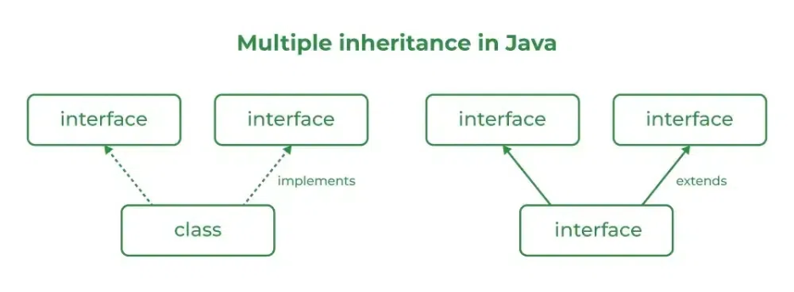

Source Code
import java.io.*;
// Add interface
interface Add{
int add(int a,int b);
}
// Sub interface
interface Sub{
int sub(int a,int b);
}
// Calculator class implementing Add and Sub
class Cal implements Add , Sub
{
// Method to add two numbers
public int add(int a,int b){
return a+b;
}
// Method to sub two numbers
public int sub(int a,int b){
return a-b;
}
}
class Example{
// Main Method
public static void main (String[] args){

// instance of Cal class
Cal x = new Cal();
System.out.println("Addition : " + x.add(2,1));
System.out.println("Substraction : " + x.sub(2,1));
}
}

Outputs
Addition : 3
Subtraction : 1
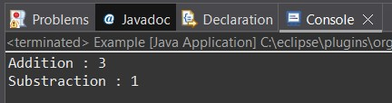
POST LAB EXERCISE
  - Can a functional interface extend another interface?
Yes.
A functional interface can extend another interface,
as long as it still has only one abstract method
  - Which feature was introduced in interfaces starting from Java 8?
- Constructors
- Private methods
- Default and static methods
- Final classes
C.Default and static methods
Reason:
From Java 8, interfaces can have:
- default methods (with body)
- static methods
This helps avoid breaking existing code and supports more flexible API design.

ASSESSMENT

Description | Max Marks | Marks Awarded
Pre Lab Exercise | 5
In Lab Exercise | 10
Post Lab Exercise | 5
Viva | 10
Total | 30
Faculty Signature

Experiment Number : 12 Date: 02.03.26

Implementation of exception handling in Java
Aim:
Write a java program to implement exception handling.

PRE LAB EXERCISE
QUESTIONS
- What is exception handling in Java?
Exception handling in Java is a mechanism to detect and handle runtime errors so that the normal flow of the program is not interrupted.
It prevents the program from crashing and allows graceful error management.

- What is the purpose of using try-catch blocks in exception handling?
The try-catch block is used to enclose risky code (in try) and handle the error (in catch) to prevent the program from terminating abnormally.
try: contains code that may throw an exception
catch: handles the exception safely

IN LAB EXERCISE
Objective
To understand and implement exception handling through try-catch and finally blocks.
Source Code
import java.util.InputMismatchException;
import java.util.Scanner;
public class ExceptionHandlingExample {
public static void main(String[] args) {
Scanner scanner = new Scanner(System.in);
try {
System.out.print("Enter an integer: ");
int num = scanner.nextInt();
int result = 10 / num;
System.out.println("Result: " + result);
} catch (InputMismatchException e) {
System.out.println("Invalid input! Please enter an integer.");
} catch (ArithmeticException e) {
System.out.println("Cannot divide by zero!");
} finally {
scanner.close();
System.out.println("Program execution completed.");
} }
}
Outputs
Output 1 (Valid Input - Non-zero Integer):
Enter an integer: 5
Result: 2
Program execution completed.
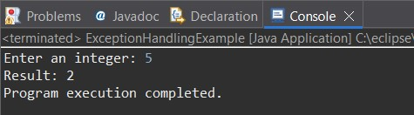
Output 2 (Valid Input - Zero):
Enter an integer: 0
Cannot divide by zero!
Program execution completed.
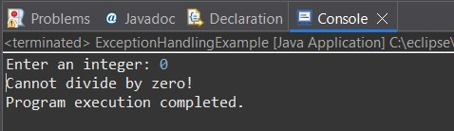
Output 3 (Invalid Input - Non-integer):
Enter an integer: abc
Invalid input! Please enter an integer.
Program execution completed.
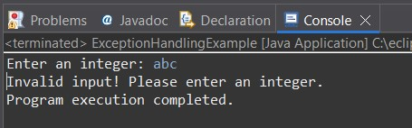

POST LAB EXERCISE
- What is the purpose of the Scanner object in the Java program?
The Scanner object is used to read user input from different input sources such as:
Keyboard (System.in)
Files
Strings
It allows reading data like int, float, double, String, etc.

- What exceptions are expected to be thrown in the code within the try block? Why?
The expected exceptions are:
InputMismatchException
Occurs when the user enters a value that does not match the expected data type
(e.g., entering a string when the program expects a number).
NoSuchElementException
Occurs when no input is available or the input is unexpectedly terminated.
IllegalStateException
Occurs if the Scanner is closed and then used again.

ASSESSMENT

Description | Max Marks | Marks Awarded
Pre Lab Exercise | 5
In Lab Exercise | 10
Post Lab Exercise | 5
Viva | 10
Total | 30
Faculty Signature

Experiment Number : 13 Date: 02.03.26

Implementation of User-defined Exception in Java

Aim:
Write a java program to implement User-defined Exception.

PRE LAB EXERCISE
QUESTIONS
- What is Java custom exception?
A Java custom exception is a user-defined exception created by extending the Exception or RuntimeException class.
It allows programmers to create meaningful and specific error messages for application-specific errors.

- What are the two types of custom exceptions in Java?
The two types of custom exceptions are:
Checked Custom Exception
Created by extending Exception
Must be handled using try-catch or throws
Unchecked Custom Exception
Created by extending RuntimeException
Does not require mandatory handling

IN LAB EXERCISE
Objective
To understand and implement Checked and Unchecked custom exceptions.
Source Code
Ex 1: // Custom Checked Exception
class InvalidAgeException extends Exception {
public InvalidAgeException(String m) {
super(m);
}
}
// Using the Custom Exception
public class AgeCheck{
public static void validate(int age)
throws InvalidAgeException {
if (age < 18) {
throw new InvalidAgeException("Age must be 18 or above.");
}
System.out.println("Valid age: " + age);
}
public static void main(String[] args) {
try {
validate(12);
} catch (InvalidAgeException e) {
System.out.println("Caught Exception: " + e.getMessage());
}
}
}

Output 1
Caught Exception: Age must be 18 or above.
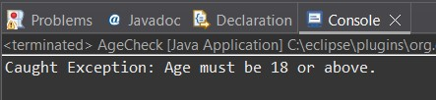
Ex 2: // Custom Unchecked Exception
class DivideByZeroException extends RuntimeException {
public DivideByZeroException(String m) {
super(m);
}
}
// Using the Custom Exception
public class TestSample {
public static void divide(int a, int b) {
if (b == 0) {
throw new DivideByZeroException("Division by zero is not allowed.");
}
System.out.println("Result: " + (a / b));
}
public static void main(String[] args) {
try {
divide(10, 0);
} catch (DivideByZeroException e) {
System.out.println("Caught Exception: " + e.getMessage());
}
}
}

Output 2
Caught Exception: Division by zero is not allowed.
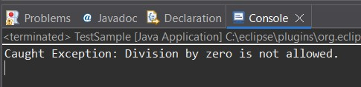
POST LAB EXERCISE
- What is required to create a custom exception in Java?
- Extend the Object class
- Extend the Throwable class
- Extend Exception or RuntimeException
- Implement the Serializable interface
C. Extend Exception or RuntimeException
To create a custom exception, you must extend either:
- Exception → for a checked custom exception
- RuntimeException → for an unchecked custom exception

- List some use cases for the checked and unchecked exceptions.
Checked Exceptions (must be handled)
Used for anticipated, recoverable problems, such as:
File not found
Invalid file format
Database connection failure
Missing network connection
Class not found
Unchecked Exceptions (occur at runtime)
Used for programming errors, such as:
Dividing by zero
Null pointer usage
Array index out of bounds
Invalid type casting
Illegal argument passed to a method

ASSESSMENT

Description | Max Marks | Marks Awarded
Pre Lab Exercise | 5
In Lab Exercise | 10
Post Lab Exercise | 5
Viva | 10
Total | 30
Faculty Signature

